

My Personal Career Plan

ICA – My Personal Career Plan

(Individual Assignment 45 Marks)

|  |
| --- |
| 1. **My Profile** |
| * 1. My Career Interests (RIASEC)   2. My Career Values   3. My Personality Traits and Skills   4. MySkillsFuture Profile and Skills Passport |
| 1. **My Network** |
|  |
| 1. **Research, Explore and Evaluate Career Options** |
|  |
| 1. **My Education and Career Goals** |
|  |

**My Personal Career Plan**

Developing a career plan helps you maintain a sense of direction and keeps you focused towards a purposeful goal.

Name:Govindaraju Thooyavan 212988H

Diploma and Expected Graduation Year: Diploma in ICT , 2024

Career Plan Submission Date/Update: 13/02/2022

|  |
| --- |
| **1.** **My Profile** |
| Understanding yourself is a crucial step in charting out your career plan. PCS1 allows you to identify your career interests, values, skills and personality traits. Knowing how to leverage on your positive qualities and strengths will help you excel in school and at work. |
| **1.1 My Career Interests (RIASEC)** |
| Refer to Topic 1.2 My Career Interests - Please attach a copy of your Career Interests self-assessment results from MySkillsFuture portal. The three personality types with the highest scores make up your RIASEC results. Refer to Annex A for instructions. |
| **1.2 My Career Values** |
| Refer to Topic 1.3 My Career Values - Please attach a copy of your Work Values self-assessment results (outlining your top 5 most important values) from MySkillsFuture portal. Refer to Annex A for instructions. |

|  |
| --- |
| **1.3 My Personality Traits and Skills** |
| *(Refer to SDL Prelude to Topic 2.2 – Worksheet 2.2.1 - Identify Your Skills.)*   1. List your top ten Skills: three Adaptive Skills / Personality Traits, five Transferable Skills and two Job-related / Technical Skills.  |  |  |  | | --- | --- | --- | | **Adaptive skills / Personality Traits** | **Transferable Skills** | **Job-related /**  **Technical Skills** | | (1)cheerful | (1)Researching | (1)Managing stocks | | (2)hardworking | (2)Analysing | (2)Leading a team | | (3)confident | (3)  Achieving results |  | |  | (4)Measuring |  | |  | (5)Repairing |  |  1. What skills are needed in today’s economy? Please quote at least one “Premium” article from the Straits Times Online[1]. Which of these skills would you like to develop and why?   ________________ https://www.straitstimes.com/singapore/strengths-of-the-singapore-workers _______________We need to be soft skill, creativity and risk taking. I want to develop in risk-taking as it will make me come out of my comfort zone.  ____________________________________________________________________________________________  _____________________________________________________________________________________________   1. Please attach a copy of your Skills Confidence self-assessment results from MySkillsFuture portal. Refer to Annex A for instructions. |
| **1.4 My SkillsFuture Profile and Skills Passport** |
| Please update your MySkillsFuture Profile and Skills Passport – Skills and Certificates (where appropriate). Refer to Annex B for instructions. |
| **2.** **My Network** |
| *(Refer to Topic 2.3 Class Activity Worksheet – Connectedness)*  List the resource persons who can support you in your education and career planning journey and share how you may start conversations on education and career planning with them.  Father and Uncle. They have the most experience in terms of work. I am sure that they will  ___________________________________________________________________________________________  _be to help me and tell me if I am going in the right direction.  ___________________________________________________________________________________________  ____________________________________________________________________________________________  ____________________________________________________________________________________________ |

|  |  |  |  |
| --- | --- | --- | --- |
| **3. Research, Explore and Evaluate Career Options** | | | |
| *(Refer to Topic 3.2 and Section 1 of Personal Career plan.)*  Students in Common Entry Programmes – Consider all Diploma or Track options in your evaluation. Research and explore the features of jobs related to the Diplomas and Tracks and identify which option is best aligned to your decision-making factors.  Students Choosing Specialisation – Consider all Specialisation options in your evaluation.  Students not required to choose Diploma, Track or Specialisation – Consider three possible job options that you might embark on upon graduation from NYP.  Career Decision-making Matrix  How aligned/congruent are your decision-making factors (e.g. career interests, values, personality traits, skills) with the various career options you are considering?  Assign a "rating" (from below) to each factor-option pair and then total each column.   |  |  |  |  |  | | --- | --- | --- | --- | --- | | 5 | 4 | 3 | 2 | 1 | | Very Congruent | Congruent | Maybe Congruent | Incongruent | Very Incongruent |  |  |  |  |  | | --- | --- | --- | --- | |  | **Career Options Under Consideration** | | | | **Decision-Making Factors** *(e.g. Family, Work-life balance, honesty and Integrity, Knowledge, creativity, challenging problems, help others, work with others, high income anticipated, etc.)* | **Option 1:** | **Option 2:** | **Option 3:** | | *knowledge* | 4 | 4 | 4 | | *Work life balance* | 3 | 3 | 4 | | *Leadership* | 2 | 3 | 4 | | *High Income* | 4 | 3 | 2 | | *Teamwork* | 3 | 3 | 4 | | *Creativity* | 2 | 3 | 4 | |  |  |  |  | |  |  |  |  | |  |  |  |  | | Total | 18 | 19 | 22 | | | | |
| |  | | --- | | **4. My Education and Career Goals** |   **SMART** GOALS:  **S**pecific: be as clear as you can and avoid ambiguous statements.  **M**easurable: so you can see what you have achieved.  **A**chievable: provides motivation, but also keep your goals reachable.  **R**ealistic: be reasonable and avoid the realms of fantasy.  **T**imely: create timeframes for completing steps, for example, doing short courses or talking with someone about the skills required for a particular job. | | |
| The goals are meant to be empowering and reviewable. Be as specific as possible with your goals, listing specific knowledge, skills, or experience to be acquired or developed. | |
| **Education and Career Goals** | **Target Date** | | |
| (e.g. within 1 year – What CCAs, volunteer work, competitions should I take part in?)  Within 1 year, I would like to join a cca and also join in programms involving coding.  (e.g. 1 to 3 years - What do you plan to do after NYP? Further your studies, get a job, join Work-Study Programme?)  After my time in NYP, I want to get into a local Uni. Getting into a uni will be my goal | Two months break  2 years | | |

**Annex A - Complete Self-assessments on MySkillsFuture Portal**

(You can refer to the MySkillsFuture Portal Login Guide in Topic 1.1 for Login assistance.)

Login to MySkillsFuture Portal and do the following profiling at the Assessments Section:

1. Career Interests
2. Skills Confidence
3. Work Values

* Click **“Resources”** tab
* Click **“Find out more” in Assessment section**

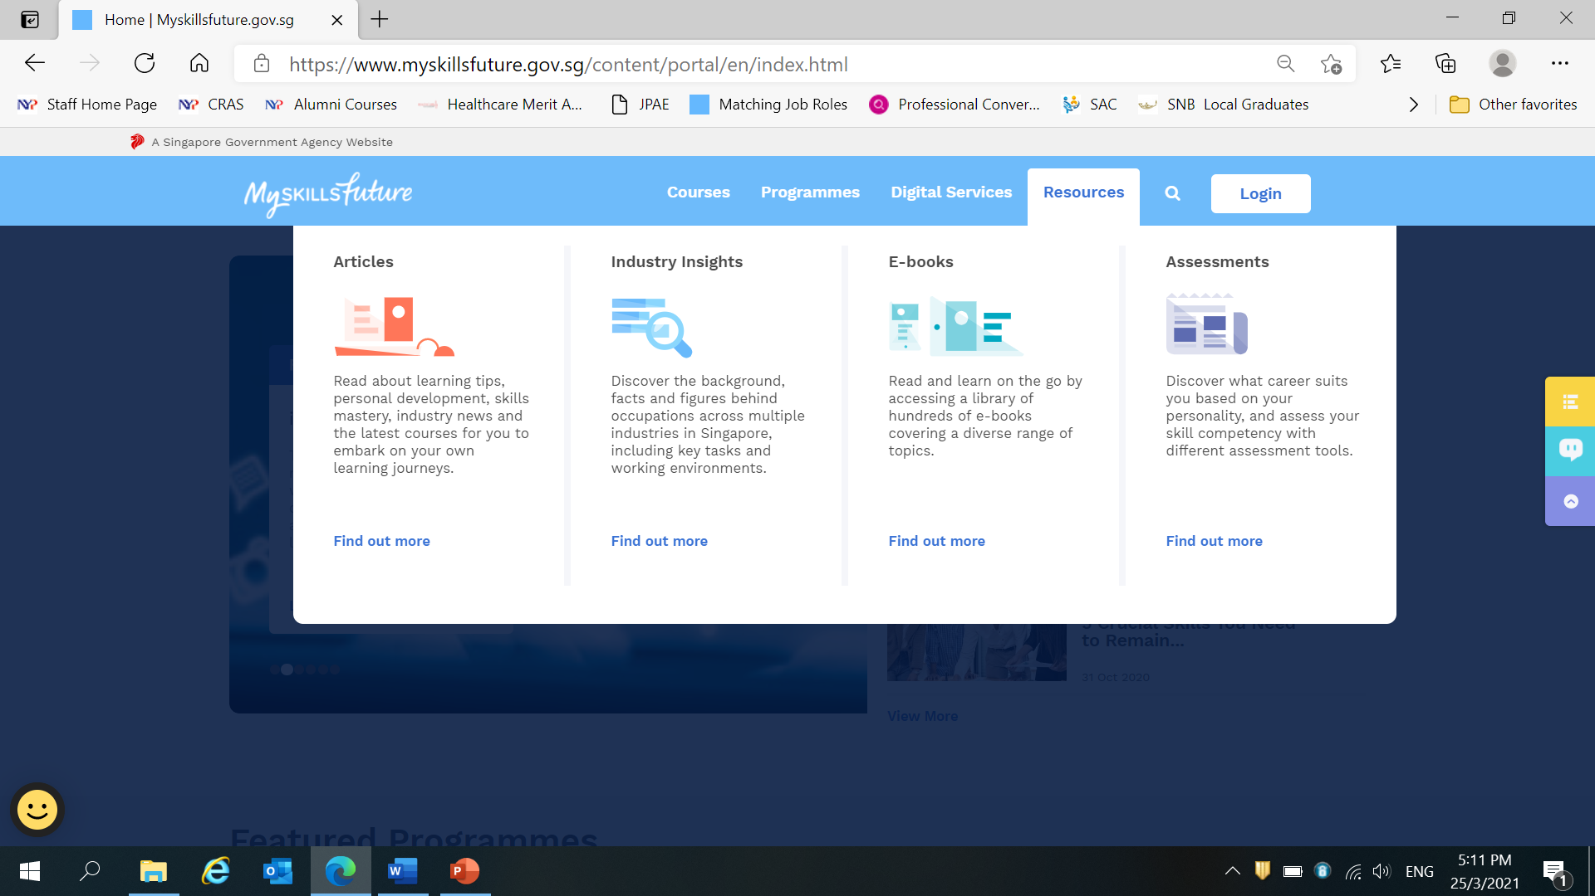



Once you have completed the 3 profiling, please be reminded to attach a copy of the results to your Personal Career Plan. You can refer to the sample copy below.

Career Interest

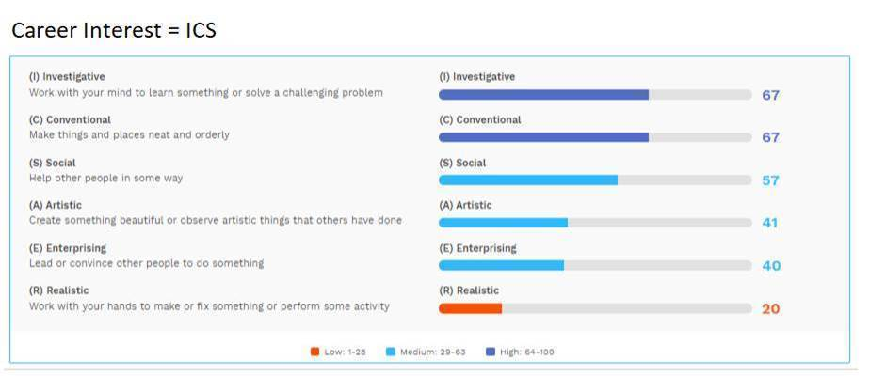

Work Values

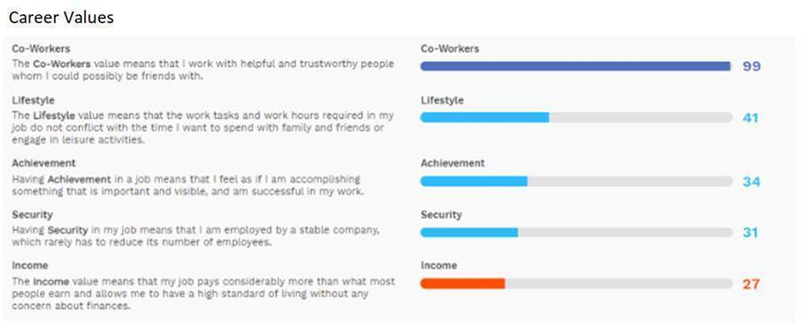

Skills Confidence

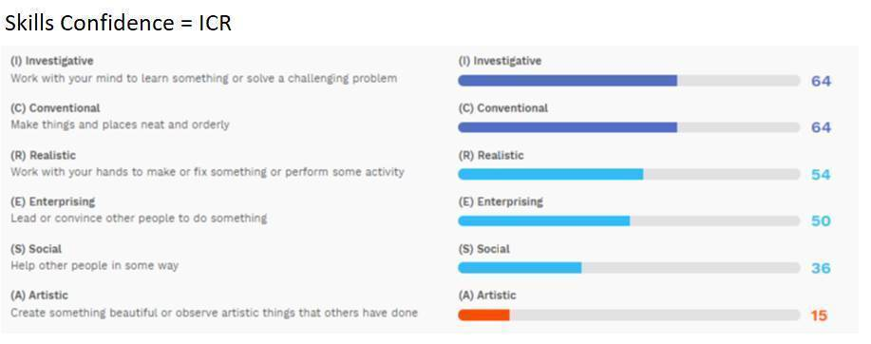

**Annex B - Update Your Profile and Skills Passport on MySkillsFuture Portal**

Login to MySkillsFuture Portal and update the following sections:

1. Profile
2. Skills Passport - Skills
3. Skills Passport - Certificates

Profile

After login, click on “Your ID” and Select “Profile” from the drop-down list.

The Profile page is where you can upload and edit information about yourself pertaining to your career.

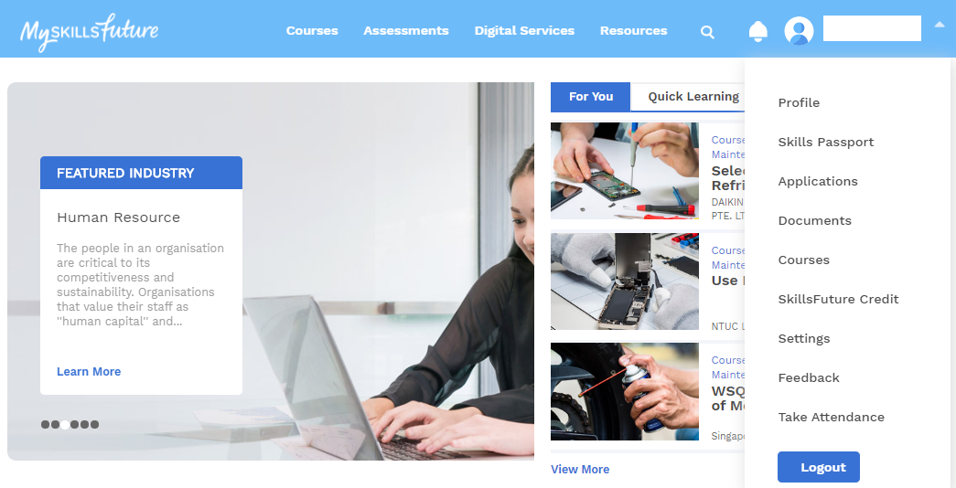

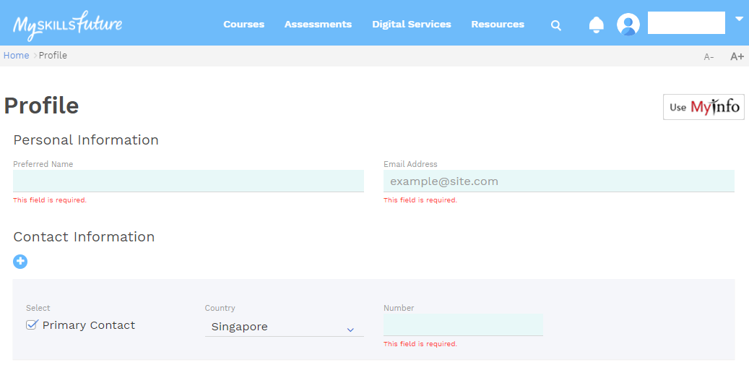

Skills Passport – Skills and Certificates



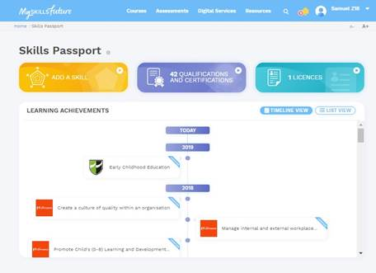

Skills

Qualifications and Certifications

* You can add generic and technical skills. Skills listed are taken from Skills Frameworks. You can add skills outside of Skills Frameworks. You can also indicate the proficiency level of your skills.

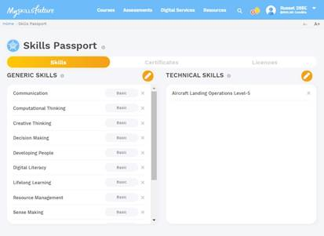

* Certificates can be uploaded by Training Providers, educational institutions or individuals. They can be in PDF as e-Certificates or OpenCert, a new, tamper-proof digital format. Certificates uploaded by Training Providers and educational institutions will appear with a blue ‘Verified’ label at the top right. For now, only Statements of Attainment and WSQ qualifications are available. You will be able to view and download your qualifications or upload new qualifications.

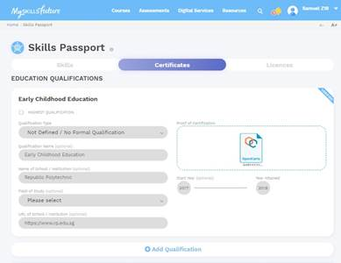

ICA – Financial Literacy 1

(Individual Assignment 20 Marks)

**Completion Report of Financial Literacy Module**

Attach completion report (from Blackboard) of the following from the Financial Literacy Module 1.

1. Pre-Course Survey
2. Topic 1 – What is Financial Literacy?
3. Topic 2 – Set your SMART Financial Goals (including Quiz)
4. Topic 3 – Budgeting (including Quiz)
5. Topic 4 – Compound Interest (including Quiz)
6. Post-Course Assessment
7. Feedback

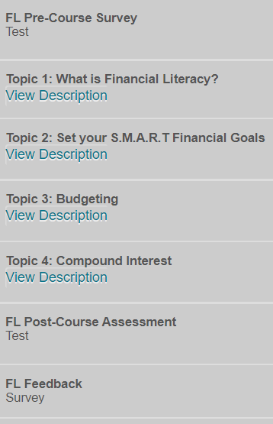

Example of “My Grades” in Blackboard

1. All NYP students are given an ST Online account accessible by NYP student email address.